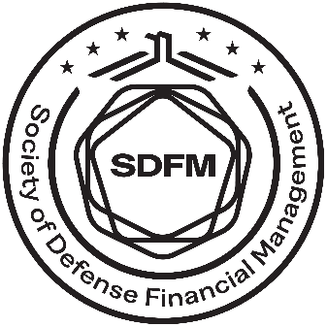
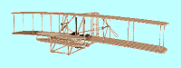

SOCIETY OF DEFENSE FINANCIAL MANAGEMENT

AVIATION CHAPTER
P.O. BOX 33215
WRIGHT-PATTERSON AFB OH 45433

MONTHLY LUNCHEON
CONTINUING PROFESSIONAL EDUCATION (CPE)
CERTIFICATE OF TRAINING
DATE OF LUNCHEON: 21 April 2026, 11:30am-12:42pm

NAME OF ATTENDEE: |  | OFFICE SYMBOL:
NAME OF SPEAKER
Mr. Justin Clark, AFLCMC/FZA
TOPIC: | Embrace Change
PLACE:
Virtual: AF Teams

1.0 CPE UNITS

I certify that the above information is correct.

Member’s Signature________________________________________________ DATE ________________________

I certify the above information is correct.

Supervisor’s Signature______________________________________________ DATE ________________________

PRIVACY ACT STATEMENT
AUTHORITY: 10 U.S.C. 8013, Secretary of the Air Force.
PURPOSE AND USE: To document continuing professional education performed by Financial Managers.
DISCLOSURE: Furnishing the information is voluntary. Failure to do so; however, may result in lost credit for CPE earned.

