|  |  |  |  |
| --- | --- | --- | --- |
| |  |  |  | | --- | --- | --- | | BioSeal | Biography | Flag | |
| ***U N I T E D   S T A T E S   A I R   F O R C E*** |
|  |

**Todd M. Baker, SL, DAF, CDFM**

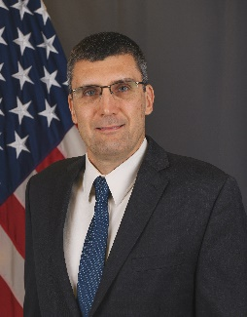Todd Baker is the Senior Financial Management Operations and Business Transformation Advisor for the Office of the Deputy Assistant Secretary of the Air Force for Financial Management and Comptroller. Mr. Baker is responsible for supplying strategy and planning expertise related to the integration, standardization, and implementation of enterprise architecture for Financial Management transformation initiatives across SAF/FM, as well as other DAF business systems. He provides guidance on transformation policy and procedures, and leads the planning and implementation of change management initiatives to achieve full integration of financial transformation/business reform activities. Additionally, he represents FM interests and requirements for new capabilities, interfaces, program sustainment, and user experience to improve organizational processes with non-FM stakeholders.

Mr. Baker began his career as an officer in the US Army Corps of Engineers before transitioning to the private sector working in operational, accounting, and auditing positions until joining Civil Service in 2011. He has served in the Office of the Deputy Assistant Secretary for Financial Operations in policy, financial reporting, and compliance positions, and led the Defense Enterprise Accounting and Management System Functional Management Office. He holds the Defense Financial Management, Level III certification and is a Certified Defense Financial Manager.