|  |  |  |  |
| --- | --- | --- | --- |
| |  |  |  | | --- | --- | --- | | Seal | Biography | Flag | |
| ***U N I T E D   S T A T E S   A I R   F O R C E*** |

JAMES D. “JD” LAWSON

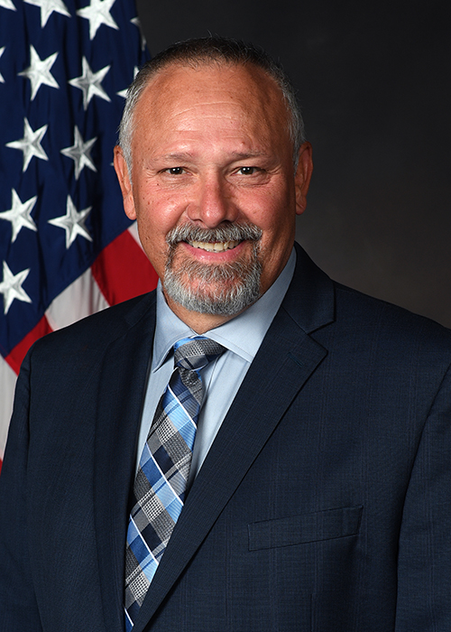James D. “JD” Lawson is the Director of the Air Force Accounting Operations Center, Wright-Patterson AFB, OH. He is responsible for providing field support, help desk operations, functional subject matter area support, strategic communication, interface monitoring, data analytics & continuing education & training to Air Force financial system users worldwide.

Mr. Lawson entered Federal Service in December 1979 as an Air Force enlistee and served 25 years in the Financial Management career field at several duty locations to include RAF Mildenhall UK, McClellan AFB CA, RAF Alconbury UK, Ramstein AB GE, McGuire AFB NJ, Osan AB ROK, Fairchild AFB WA, Incirlik AB TU, and Wright-Patterson AFB OH.

Upon retirement from the Air Force he entered the private sector, initially providing contractor support to HQ Air Force Materiel Command Financial Management as the Commanders Resource Integration System Functional Analyst and as an FMSuite Functional Analyst in the Air Force Financial Systems Operations. He entered the Federal Civil Service in July 2008.

# Education

1988 Non-Commissioned Officer Leadership School, March AFB, CA

1990 Non-Commissioned Officer Academy, Norton AFB, CA

1993 Associates of Applied Science degree in Financial Management, Community College of the Air Force

1994 Financial Management Staff Officer Course, Sheppard AFB, TX

1997 Senior Non-Commissioned Officer Academy, Gunter Annex, Maxwell AFB, AL

2003 Bachelors of Science degree in Management/Accounting, magna cum laude, Park University

2008 Master of Arts degree in Management/Leadership, Webster University

2009 Defense Financial Management & Comptroller School, Maxwell AFB, AL

2018 Air Force Civilian Leadership Course

2018 OPM Team Development

2019 OPM Leading Change & Innovation

2019 OPM Leading Effectively Through Change

# CAREER CHRONOLOGY

1. Dec 1979 – July 1999, numerous financial management positions while on Air Force Active Duty, including military pay & travel, commissary accounting, commercial services, QA, and financial analysis

2. Aug 1999 – Aug 2000, Superintendent, 607th Accounting & Finance Squadron, Osan AB, Korea

3. Sep 2000 – June 2002, Superintendent, 92nd Comptroller Squadron, Fairchild AFB, WA

4. July 2002 – Aug 2004, Superintendent, Aeronautical Systems Center FM & 88th CPTS, WPAFB, OH

5. Sept 2004 – June 2008, financial management functional analyst, Computer Sciences Corporation

6. July 2008 – May 2010, FMSuite Program Manager, Air Force Financial Systems Operations, WPAFB, OH

7. May 2010 - Dec 2013, Budget Analyst, National Air & Space Intelligence Center, WPAFB, OH

8. Dec 2013 – May 2015, DEAMS Deployment Team, DEAMS Functional Management Office, WPAFB, OH

9. May 2015 – June 2017, Chief, DEAMS Customer Support Division, Wright-Patterson AFB, OH

10. June 2017 – March 2019, Director, DEAMS Operations Center, Wright-Patterson AFB, OH

11. April 2019 – Present, Director, Air Force Accounting Operations Center, Wright-Patterson AFB, OH

# awards and HONORS

Meritorious Service Medal with three oak leaf clusters

Joint Service Commendation Medal

Air Force Commendation Medal with three oak leaf clusters

Air Force Achievement Medal

National Defense Service Medal

Korean Service Medal

Southwest Asia Service Medal

Humanitarian Service Medal

# PROFESSIONAL MEMBERSHIPS AND AFFILIATIONS

American Society of Military Comptrollers

# PROFESSIONAL CERTIFICATIONS

Defense Financial Management Certification Program – Level 3

Certified Defense Financial Manager

# OTHER ACHIEVEMENTS

1988 - Distinguished Graduate, NCO Leadership School

1990 - Distinguished Graduate, NCO Academy

1991 - 10th Comptroller Squadron NCO of the Year

1992 - 10th Comptroller Squadron NCO of the Year

1993 - United States Air Forces in Europe Financial Analysis Airman of the Year

1995 - 86th Airlift Wing Senior NCO of the Year

1995 - United States Air Forces in Europe Financial Services Airman of the Year

2015 - Secretary of the Air Force Financial Operations (SAF/FMF) Civilian of the Year (GS12 – GS14)

(Current as of May 2019)